TELEMEDICINE AND HEALTH CARE SYSTEMS

TABITHA TIBIN BARUE.

The presented research project is submitted to the School of Science Engineering and Technology of Kabarak University as part and key requirement for the attainment of a certificate in Diploma in Information Technology, Kabarak University.

DECEMBER, 2025.

COPYRIGHT
©2025
No part of this report may be reproduced, stored in a retrieval system, or transmitted in any form or by any means either electronic, mechanical, photocopying, recording, or otherwise without prior written permission from the author and the engineering department of Kabarak University.
Sign:____________________ Date:_________________

DECLARATION AND APPROVAL.
This project report entitled "Telemedicine and health care systems" is my original work and has not been presented for a diploma or any other award in the School of Science Engineering and Technology, Kabarak University beyond any reasonable doubt.
Sign:_________________ Date:___________________
Name: TABITHA TIBIN
Reg no: DIT/N/0991/05/24

RECOMMENDATION.
This research project entitled Telemedicine and health care systems done by Tabitha Tibin is presented to the School of Science Engineering and Technology, Kabarak University. I have reviewed this project and recommend that it will be accepted in partial fulfilment of the requirements for the Diploma in Information Technology.

Signature:________________ Date___________________
Prof. Elvin Saikwa
School of Science Engineering and Technology
Department of Computer Science and Information Technology
Kabarak University

ACKNOWLEDGEMENT.
I sincerely thank Almighty God for the gift of life and strength to complete this project. I am deeply grateful to my supervisor, Elvis Saikwa, for his guidance and support throughout this work. My appreciation also goes to my lecturers, family, and friends for their encouragement and assistance for valuable insights. Also not forgetting the school for the provision of the necessary resources to ensure successful completion of this study.

DEDICATION.
I would like to dedicate this project to my beloved family for their endless love, support, and encouragement, and to my friends and mentors who inspired me throughout this journey.

ABSTRACT.
Telemedicine is a platform that connects patients with healthcare providers via video, messaging, and asynchronous consultations. The system supports appointment booking, clinical workflows, EHR integration, remote monitoring, prescriptions, billing, reporting, and compliance with healthcare privacy regulations.
Keywords: EHR

TABLE OF CONTENTS
COPYRIGHT ii
DECLARATION AND APPROVAL. iii
RECOMMENDATION. iv
ACKNOWLEDGEMENT. v
DEDICATION. vi
ABSTRACT. vii
LIST OF FIGURES xi
LIST OF TABLES xii
CHAPTER ONE 1
INTRODUCTION 1
1.1 Introduction 1
1.2 Background 1
1.3 Problem statement. 2
1.4 Purpose of the study. 2
1.5 Objective of the study. 3
1.5.1General objective 3
1.5.2 Specific objectives. 3
1.6 Research Questions. 3
1.7 Justification of the study. 3
1.8 Scope of the study. 3
1.9 Limitation of the study. 3
1.10 Assumptions. 4
CHAPTER TWO 5
LITERATURE REVIEW 5
2.0 Introduction 5
2.1 Telemedicine Practice and Patient Management 5
2.2 Challenges Facing Traditional Healthcare Delivery 5
2.3 Related Works 6
2.3.1 Web-Based Consultation Platforms 6
2.3.2 Mobile Telemedicine Applications 6
2.3.3 Local Initiatives and Research 6
2.4 General Gaps in Existing Systems 6
2.5 Conceptual Framework 7
CHAPTER THREE 8
RESEARCH METHODOLOGY 8
3.0 Introduction 8
3.1 System Development Methodology 8
3.1.1 Requirements Analysis 9
3.1.2 Design 9
3.1.3 Develop 9
3.1.4 Testing 9
3.1.5 Maintenance 9
3.1.6 Feedback 10
3.2 Justification of Methodology 10
3.2.1 Functional Requirements 10
3.2.2 User Login and Authentication 10
3.2.3 Virtual Consultations 10
3.2.4 Medical Record Display 10
3.2.5 Record Storage 10
3.3 Non-functional Requirements 10
3.3.1 Usability 10
3.3.2 Reliability 10
3.3.3 Security 11
3.4 Tools and Techniques 11
3.4.1 Visual Studio Code (VS Code) 11
3.4.2 CSS 11
3.4.3 Next.js 11
3.4.4 Supabase 11
3.4.5 Node.js Environment 11
3.4.6 Microsoft Word 11
3.5 Milestones and Deliverables 11
3.5.1 Telemedicine System 11
3.5.2 Administrator Module 12
3.5.3 User Manual 12
3.6 Data Collection Methods 12
3.6.1 Primary Data Collection Methods 12
3.6.2 Secondary Data Collection Methods 12
3.7 Data Flow Diagram 12
3.7.1 Context Diagram – Level 0 12
CHAPTER FOUR 14
SYSTEM ANALYSIS, IMPLEMENTATION AND DESIGN 14
4.0 Introduction 14
4.1 Input Design 14
4.1.1 User Login Screen 14
4.1.2 Consultation Request Form 15
4.1.3 Dashboard Screen 15
4.1.4 Dashboard Screen 15
4.2 Description of the Implementation 15
4.2.1 chat page 15
4.2.2 video call 16
4.2.1 Hardware Specification 16
4.2.2 Software Specification 17
4.3 Description of Testing and Results 17
4.3.1 System Testing 17
4.3.2 Testing and Data Results 17
4.3.3 Non-functional Requirements 17
4.4 Description of Results 18
CHAPTER FIVE 19
CONCLUSION AND RECOMMENDATION 19
5.0 Introduction 19
5.1 Conclusion 19
5.2 Recommendation 19
5.3 Future Works 19
REFERENCES 21

LIST OF FIGURES
Figure 1 conceptual framework 7
Figure 2 agile methodology 8
Figure 3: level 0 dfd 13
Figure 4: User login 14
Figure 5 dashboard 15
Figure 6: Booking 16
Figure 7: Video call: 16

LIST OF TABLES
Table 1: testing and data results 17
Table 2: Non-functional requirements: 17

CHAPTER ONE

INTRODUCTION

Introduction
Telemedicine is a digital healthcare platform that connects patients with healthcare providers through video consultations, real-time messaging, and asynchronous store-and-forward communication, enabling flexible care delivery regardless of geographical distance (Smith, 2021). Modern telemedicine systems support a wide range of functionalities, including appointment scheduling, automated reminders, and integrated clinical workflows designed to streamline patient–provider interactions (Johnson & Patel, 2020). These platforms often include electronic health record (EHR) integration, allowing clinicians to access patient histories, update medical information, and document encounters efficiently during virtual visits (Andrews, 2022). Additionally, telemedicine incorporates remote patient monitoring tools that track vital signs and chronic conditions using connected devices, providing clinicians with continuous data to support informed decision-making (Lee & Carter, 2023). Beyond clinical care, telemedicine systems also facilitate electronic prescriptions, digital billing, automated payment processing, and detailed reporting features that assist in administrative and operational management (Dawson, 2020). To ensure patient safety and confidentiality, these platforms are designed to comply with healthcare privacy and data-security regulations such as HIPAA or GDPR, depending on the region (Martinez, 2021). Overall, telemedicine enhances access to healthcare, reduces physical barriers, and supports efficient, integrated, and secure delivery of medical services.

1.2 Background
This research paper explores the potential of telemedicine as a new approach to providing healthcare in rural and underserved areas. The objectives of the study were to examine the applications of telemedicine, assess its benefits and impacts, identify challenges and considerations, and analyze the policy and ethical implications associated with its implementation.
The research methodology employed a comprehensive review of the existing literature on telemedicine, including studies case reports, and policy documents. Interviews and surveys were conducted to gather primary data from healthcare providers, patients, and policymakers. The findings revealed that telemedicine offers various applications, including remote consultations with doctors, prescription delivery, and remote patient monitoring.
Numerous successful telemedicine programs were identified, demonstrating improved access to healthcare services in remote and underserved areas. The benefits of telemedicine were observed in terms of increased access to care, reduced costs, and enhanced patient satisfaction.
The research enhances the utilization and effectiveness of telemedicine in rural and underserved areas. This research paper contributes to the existing body of knowledge by providing a comprehensive analysis of the potential of telemedicine in improving healthcare delivery in underserved communities. The findings emphasize the transformative nature of telemedicine and its ability to bridge geographical barriers and improve access to healthcare services for vulnerable populations.

1.3 Problem statement.
People in rural and underserved areas are less privileged when it comes to accessing healthcare services this is mostly due to limited technological infrastructure, regulatory barriers, and privacy concerns The use of telemedicine expanded dramatically during the recent pandemic of the corona virus, as providers and patients sought to safely deliver and access healthcare services .This was mostly efficient when hospitals were congested and it increased the rate of more people contracting the disease. By the help of Telemedicine people could easily access healthcare services from their points of comfort as well as safely without having to visit hospitals or health care providers thus reducing chances of them contracting the disease which was more economical .At times most patients find it hard when visiting hospitals and find long ques which may take time and might as well fail to find the services they require at that time or on that specific day due to the busy schedules of the health care providers in that health facility.

1.4 Purpose of the study.
The objectives of the study were to examine the applications of telemedicine, assess its benefits and impacts, identify challenges and considerations, and analyze the policy and ethical implications associated with its implementation.
- The study is used to:
- provide timely accessible virtual care across devices.
- Maintain patient privacy and data security according to applicable law.
- Integrate clinical systems and workflows.
- Deliver a clinical-friendly interface that reduces administrative overhead.

1.5 Objective of the study.

1.5.1General objective
- To develop a web application that enables patients and healthcare providers interact through video calls and chats and can also get prescriptions online.

1.5.2 Specific objectives.
- To increase access to healthcare for remote populations.
- To improve health outcomes by enabling timely and specialized care.
- To reduce healthcare costs.

1.6 Research Questions.
- How do you increase the accessibility of healthcare services in remote areas?
- How do you improve the health outcome through telemedicine?
- Is telemedicine efficient in cost reduction?

1.7 Justification of the study.
The research enables us explores the potential of telemedicine as a new approach to providing healthcare in rural and underserved areas This not only applies to the rural areas but also the urban areas where they can access the health care services without having to visit the health facilities and encounter the problem of congestion or delays of services in these facilities.

1.8 Scope of the study.
  - Patient registration and identity verification.
  - Scheduling, reminders, and virtual waiting room.
  - Secure video consultations and in-app messaging.
  - Clinical notes, e-prescribing, and lab order integration.
  - Integration with EHR/EMR and practice management systems.
  - Basic remote patient monitoring (device integrations and data ingestion).

1.9 Limitation of the study.
Challenges faced when researching on telemedicine include:
- Technical limitations like inadequate internet and devices especially in the rural areas.
- Financial barriers such as lack of reimbursement and high implementation costs.
- Regulatory and legal issues including licensing and data privacy laws.
- Socio-cultural factors such as limited digital literacy.
- resistance to change from providers and patients, and the unsuitability of virtual care for certain emergency conditions.

1.10 Assumptions.
The assumption of the study made throughout this research was that patients and healthcare providers can be able to interact freely at any given time making life easy and convenient.

CHAPTER TWO

LITERATURE REVIEW

2.0 Introduction
This chapter outlines the evolution of telemedicine, the tasks normally carried out in traditional in-person healthcare, and the challenges that arise in the absence of digital consultation systems. It highlights the limitations associated with manual patient management processes such as physical record-keeping, face-to-face appointments, and paper-based prescriptions. The chapter also explores related works and existing digital health solutions, pointing out the gaps that justify the development of a modern telemedicine platform.

2.1 Telemedicine Practice and Patient Management
Telemedicine has become a significant advancement in healthcare delivery, enabling patients to receive medical care remotely through digital platforms. Traditionally, healthcare services required physical visits to hospitals or clinics, which often limited access for individuals living in remote areas, those with mobility challenges, or patients requiring urgent consultations. According to (World Health Organization, 2022), telemedicine supports timely and efficient healthcare delivery by enabling virtual consultations, remote monitoring, and digital record management.
In the traditional model, patients rely heavily on physical documentation and manual processes, creating challenges in retrieving medical history, tracking prescriptions, and maintaining continuity of care. Digital telemedicine platforms help streamline these processes by centralizing patient information, enabling real-time communication, and improving decision-making for both patients and doctors.

2.2 Challenges Facing Traditional Healthcare Delivery
Before digital solutions, healthcare systems relied on manual methods that presented several challenges. Patients were required to visit health facilities physically, which often resulted in long waiting times, travel expenses, and delays in receiving care. Additionally, physical records were vulnerable to loss, damage, and inconsistency, making it difficult for healthcare providers to access accurate patient history.
Manual prescription systems were also prone to errors, such as unreadable handwriting, incomplete dosage information, or misplaced prescription notes. According to (Telehealth Impact Study, 2021), these inefficiencies reduce the quality of patient care and hinder timely treatment. Telemedicine addresses these issues by digitizing consultations, prescriptions, and record-keeping, ensuring both accuracy and accessibility.

2.3 Related Works
Advancements in technology have led to the rise of several telemedicine tools that enhance remote healthcare delivery. Similar to the evolution seen in other digital sectors, healthcare systems are gradually adopting platforms that automate patient management tasks, streamline communication, and support digital record-keeping.

2.3.1 Web-Based Consultation Platforms
Several healthcare institutions use web-based systems that enable patients to book appointments, consult doctors via video calls, and access their medical information. These platforms allow doctors to update patient records, prescribe medication, and track progress over time. However, some systems require strong technical infrastructure and may be costly for smaller health facilities to implement.

2.3.2 Mobile Telemedicine Applications
Mobile applications such as Babylon Health and MyChart allow users to chat with doctors, receive digital prescriptions, track symptoms, and access personal medical records. They provide convenience and real-time communication through smartphones. Despite their value, such applications may require stable internet access and sometimes impose subscription fees, limiting accessibility in low-income or rural communities.

2.3.3 Local Initiatives and Research
Local health organizations have begun training healthcare workers on the use of digital tools to improve patient management. For instance, community health programs in Kenya have adopted mobile consultation systems to support remote diagnosis and follow-up care. Training initiatives focus on digital literacy, data entry accuracy, and proper use of electronic medical records to enhance service delivery (Kenya eHealth Strategy, 2020).

2.4 General Gaps in Existing Systems
While existing telemedicine platforms offer significant improvements, they still face various limitations. Many systems require high-speed internet connections, advanced devices, or costly subscription plans, making them inaccessible to some users. Some platforms are complex and not user-friendly, making it difficult for patients or doctors with limited digital literacy to adopt them fully.
Furthermore, certain systems do not integrate features such as real-time chats, secure authentication, digital prescriptions, or efficient storage of patient records. These gaps make it difficult to achieve seamless communication and comprehensive healthcare delivery. There is therefore a need for an affordable, secure, and easy-to-use telemedicine system that supports remote consultations, medical record management, and digital prescriptions.

2.5 Conceptual Framework
The diagram provides an overview of how the system operates when a patient interacts with it for consultations. The process begins with authentication, where users log in securely. Patients can then request consultations, submit symptoms, or chat with available doctors. The system stores this information using digital databases and processes it for display.
Healthcare providers view patient records, conduct consultations, and issue digital prescriptions through an organized dashboard. Patients can track their medical history, receive treatment instructions, and follow up when necessary. Administrators oversee system operations, ensuring data accuracy, user management, and platform maintenance. This framework ensures efficient, user-friendly, and reliable telemedicine services that bridge gaps in traditional healthcare delivery.
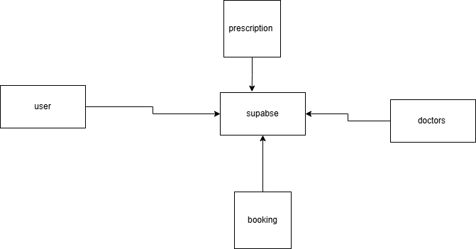
Figure 1 conceptual framework

CHAPTER THREE

RESEARCH METHODOLOGY

3.0 Introduction
The methodology used in the development of the Telemedicine System is presented in this chapter. The functional and non-functional requirements are outlined to provide an understanding of the processes involved during system development. This chapter also highlights the tools, techniques, and procedures used to structure and implement the system effectively.

3.1 System Development Methodology
The Agile methodology was adopted as the development approach. Agile assumes that requirements and solutions evolve through collaboration between developers, users, and system stakeholders. It supports iterative development, rapid adaptation to change, and continuous feedback, making it suitable for a telemedicine platform that requires frequent updates and user-driven improvements.
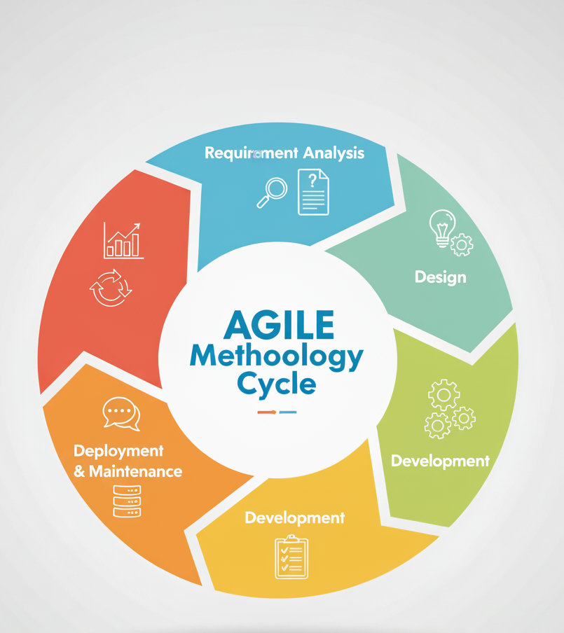
Figure 2 agile methodology

3.1.1 Requirements Analysis
The system requirements for the Telemedicine System include enabling patients to consult doctors digitally, store medical records, and receive prescriptions online. Functional requirements include patient-doctor communication, appointment scheduling, and data storage. Non-functional requirements emphasize system security, performance, reliability, and ease of use.

3.1.2 Design
The design of the Telemedicine System focused on addressing the challenges associated with traditional healthcare services such as long wait times, manual record keeping, and in-person dependency. A simple and user-friendly interface was created to allow patients to view their medical records, chat with doctors, and receive digital prescriptions easily. The system structure was designed to ensure clear data flow between patient input, doctor response, and display on the dashboard.

3.1.3 Develop
The development of the Telemedicine System was implemented using Next.js for the frontend and server-side operations, while Supabase was used as the backend database and authentication provider. Development was done in modular steps starting with user authentication, chat and consultation modules, appointment scheduling, and the prescription system. Each component was tested step-by-step to ensure the system delivered accurate and seamless interactions between doctors and patients.

3.1.4 Testing
System testing was conducted to ensure all features functioned as expected. The authentication module was tested to confirm proper user validation and role-based access control. The chat and video consultation features were tested for message accuracy and responsiveness, while the prescription module was tested for correct data input and retrieval. Errors identified during testing were corrected to improve reliability.

3.1.5 Maintenance
Maintenance involves the process of assessing the system for performance issues, errors, or areas requiring updates. This includes updating dependencies, refining user interface components, monitoring system performance, and ensuring the telemedicine platform continues to meet user needs efficiently.

3.1.6 Feedback
The feedback phase involved collecting user opinions about the system’s performance. Feedback was obtained to determine how patients and doctors rated usability, reliability, and responsiveness. This feedback was essential in improving system modules and identifying features that needed modification or enhancement.

3.2 Justification of Methodology
The Agile methodology was implemented because clients and healthcare providers often make minor changes during system development due to evolving medical and administrative needs. Agile supports these dynamic adjustments without disrupting the overall timeline. It also enhances user involvement, promoting a system that is aligned with real user requirements.

3.2.1 Functional Requirements
This section highlights the functionality of the Telemedicine System.

3.2.2 User Login and Authentication
Only registered and authorized users such as doctors and patients can access the system.

3.2.3 Virtual Consultations
Patients can request consultations and communicate with doctors through chat or video.

3.2.4 Medical Record Display
Patients and doctors can view medical history, prescriptions, and consultation notes on the dashboard.

3.2.5 Record Storage
All patient data, prescriptions, and consultation logs are stored securely in the Supabase database.

3.3 Non-functional Requirements

3.3.1 Usability
The system is easy to learn and operate. It does not require specialized skills or medical software training. A simple, intuitive design is used to avoid confusion for regular users.

3.3.2 Reliability
The system operates consistently without crashing and ensures smooth consultation sessions and accurate data retrieval.

3.3.3 Security
User data is stored securely using modern encryption and Supabase's built-in authentication and security policies to prevent unauthorized access or external threats.

3.4 Tools and Techniques
These techniques were used to build and structure the Telemedicine System. They include programming tools and environments that supported the development process.

3.4.1 Visual Studio Code (VS Code)
The primary code editor used to write, edit, and manage all files involved in the telemedicine system. It provides debugging tools and extensions that support Next.js and Supabase development.

3.4.2 CSS
Cascading Style Sheets were used to design the appearance of the system, ensuring a clean and responsive interface for both doctors and patients.

3.4.3 Next.js
Next.js was used as the web framework for creating server-side rendered pages, handling routing, API endpoints, and managing the interactive user interface.

3.4.4 Supabase
Supabase served as the backend solution responsible for authentication, database management, file storage, and real-time data interactions between users.

3.4.5 Node.js Environment
Node.js supported the development environment necessary to run Next.js and manage backend logic during development.

3.4.6 Microsoft Word
Microsoft Word was used for documentation purposes. It was used to prepare the research documentation and explain the functionalities and structure of the telemedicine system.

3.5 Milestones and Deliverables
This section explains how the research and system development contributes to the needs of the target users.

3.5.1 Telemedicine System
The main deliverable is the telemedicine application. The system allows patients to consult doctors remotely and access their medical data digitally.

3.5.2 Administrator Module
The system includes an administrator who manages user accounts, monitors database records, and ensures the platform functions correctly. The administrator oversees appointments, user authentication, and overall system organization.

3.5.3 User Manual
A user manual will be provided to guide patients and doctors on how to use the system effectively and understand its functionality.

3.6 Data Collection Methods

3.6.1 Primary Data Collection Methods
Primary data collection involved gathering information firsthand. Close-ended questionnaires and one-on-one interviews were used to collect feedback from doctors, patients, and healthcare workers. Two different questionnaires were prepared: one for patients and another for medical practitioners. This provided quantitative data about user challenges, expectations, and telemedicine adoption levels. Interviews helped determine how effectively the system addressed existing healthcare challenges.

3.6.2 Secondary Data Collection Methods
Secondary data consisted of information gathered from online journals, research articles, and health reports that discuss challenges in healthcare accessibility, telemedicine adoption, and digital healthcare transformation.

3.7 Data Flow Diagram

3.7.1 Context Diagram – Level 0
A context diagram is the first step in creating data flow diagrams. DFDs illustrate how data moves through an information system, without showing internal programming logic or processing steps. The context diagram provides a simplified overview of how the telemedicine system interacts with external users such as patients, doctors, and administrators.
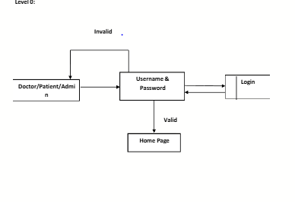
Figure 3: level 0 dfd

CHAPTER FOUR

SYSTEM ANALYSIS, IMPLEMENTATION AND DESIGN

4.0 Introduction
This chapter provides an in-depth discussion of the system’s operations and presents diagrams and models that explain how the telemedicine platform works. It also focuses on the system’s implementation and testing processes. System implementation describes how the information system was constructed, while system testing evaluates whether the complete system meets its specified functional and non-functional requirements.

4.1 Input Design

4.1.1 User Login Screen
The user login screen is the first interface patients and doctors interact with. It allows authorized users to securely access the telemedicine system using their email and password. The design is simple, secure, and user-friendly, making it suitable for individuals with varying levels of technical skill.
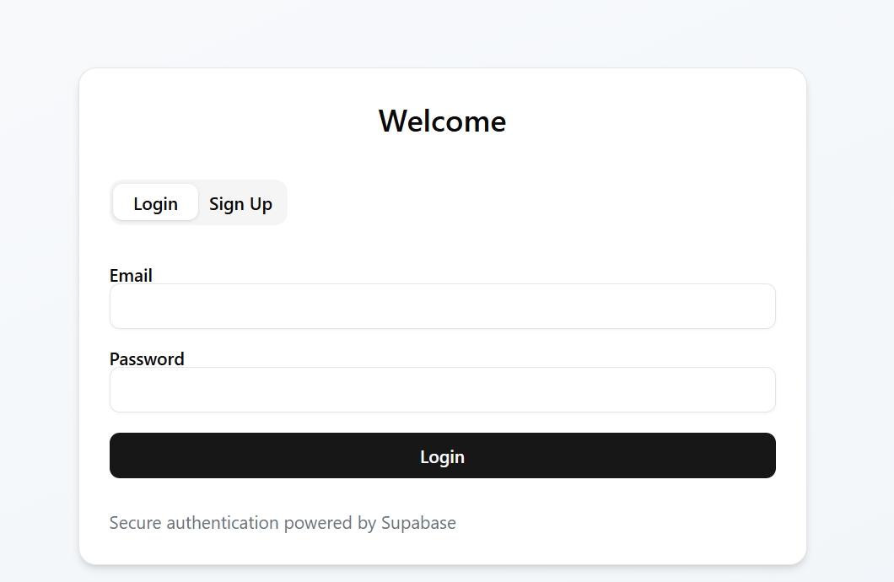

Figure 4: User login

4.1.2 Consultation Request Form
This screen enables patients to submit consultation requests by providing symptoms, preferred time of consultation, and any relevant medical notes. Once submitted, the data is stored in the database and becomes available to the doctor for review and response.

4.1.3 Dashboard Screen
The dashboard displays all consultations, medical records, and prescriptions associated with a patient or doctor. Patients can view their medical history and prescriptions, while doctors can access patient details, respond to consultations, and generate treatment instructions. The information is presented in a clean, organized table format for easy monitoring and interaction.

4.1.4 Dashboard Screen

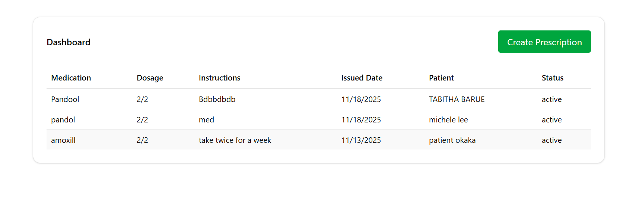
Figure 5 dashboard

4.2 Description of the Implementation
This section describes how the telemedicine system was developed and how its components operate.

4.2.1 chat page
User can communicate with doctor and get instant feedback. This is done using supabase realtime which allows for an end-to- end connection that is not closed allowing instant feedback
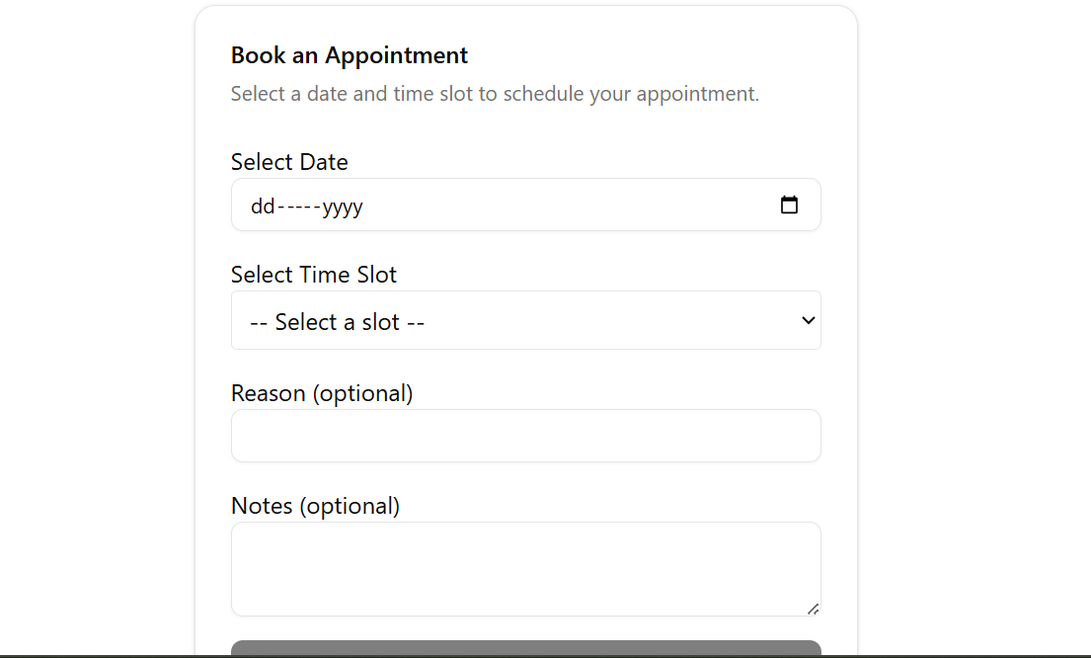
Figure 6: Booking

4.2.2 video call
Patients can have a video call with doctors which makes it possible for doctors to examine patient from anywhere in the world
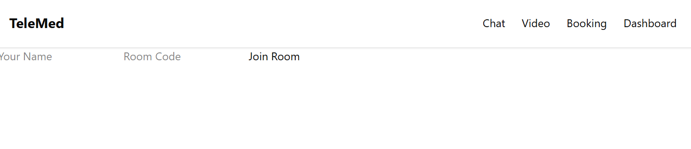
Figure 7: Video call:

4.2.1 Hardware Specification
For efficient operation, the system requires a modern computer or device. The recommended configurations include at least 8GB of storage space, 2GB of RAM, and a dual-core or quad-core processor. The telemedicine system is hosted online through Supabase, ensuring the database is available 24/7 for both patients and doctors. The system can run on mobile devices, tablets, and computers with internet access.

4.2.2 Software Specification
The Telemedicine System was developed in a web-based environment using Next.js, Supabase, HTML, CSS, and JavaScript. Supabase handles authentication, real-time communication, and database management. The system is hosted online and requires stable internet connectivity for optimal performance.

4.3 Description of Testing and Results

4.3.1 System Testing
The telemedicine system was tested using the black-box testing approach. This method evaluates whether the system meets its functional requirements without examining internal code structure. It compares the system’s expected behavior to its actual output, ensuring that all user interactions perform as intended.

4.3.2 Testing and Data Results
Table 1: testing and data results
Module | Test Carried Out | Result of the Test
User Login | Check valid login | Login successful
User Login | Check login with invalid credentials | Access denied
Consultation Input | Enter valid consultation details | Data saved successfully
Dashboard Display | Check if consultation appears on dashboard | Data displayed correctly

4.3.3 Non-functional Requirements
Table 2: Non-functional requirements:
Module | Test Carried Out | Result of Test
Usability | Check if interface is user-friendly | Interface is easy to navigate
Reliability | Test system during normal use | No crashes or errors
Performance | Measure response time | Fast and responsive
Security | Attempt access without login | Access denied
Maintainability | Make minor code updates | System continued functioning

4.4 Description of Results
The tests carried out on the telemedicine system evaluated both functional and non-functional requirements to confirm overall system quality. The system demonstrated optimal performance, with fast load times, accurate data handling, and smooth user interactions. All modules behaved as expected once development was complete. Compared to existing telemedicine tools, the system was efficient and tailored specifically for remote consultations and digital healthcare services.

CHAPTER FIVE

CONCLUSION AND RECOMMENDATION

5.0 Introduction
This chapter presents the conclusions drawn after developing and testing the telemedicine system. It also provides recommendations for effective use of the system and highlights potential future enhancements that can further improve its functionality, accessibility, and performance.

5.1 Conclusion
The Telemedicine System was developed to address the challenges associated with traditional in-person healthcare consultations, such as long travel distances, limited access to specialists, and delays in receiving medical advice. By leveraging a secure and user-friendly digital platform, patients can now book consultations, communicate with healthcare providers, and access medical information remotely.The system provides real-time interaction, improved record management, and enhanced accessibility, especially for individuals in remote or underserved areas. Through its integration of modern web technologies including Next.js and Supabase, the platform offers efficiency, reliability, and convenience in healthcare service delivery.

5.2 Recommendation
It is recommended that healthcare institutions and clinics adopt this telemedicine system to enhance patient care and improve service delivery. Users—both patients and doctors—should receive adequate training to help them navigate the system effectively.
Additionally, collaboration with the Ministry of Health and relevant stakeholders would support wider adoption, improve digital healthcare literacy, and ensure compliance with healthcare data security standards. Awareness programs could also help increase user trust and encourage more people to embrace telemedicine services.

5.3 Future Works
The system presents multiple opportunities for further development. Potential future improvements include:
The system can be improved further by integrating AI-based symptom checkers to support preliminary diagnosis and enhance user experience. Developing a mobile application for both Android and iOS would also increase accessibility and allow users to access services more conveniently. Additionally, implementing automated reminders and notification features for appointments and medication schedules would improve patient adherence. Enhancing video consultations with capabilities such as screen sharing and real-time medical file exchange would make remote interactions more effective. Finally, adding analytics and reporting tools would provide valuable health insights and support better monitoring of system usage and performance.
These additions would make the platform more robust, scalable, and beneficial to a wider range of users.

REFERENCES
Bashshur, R., Doarn, C. R., Frenk, J. M., Kvedar, J. C., & Woolliscroft, J. O. (2020). Telemedicine and the COVID-19 pandemic: Lessons for the future. Telemedicine and e-Health, 26(5), 571–573.
Dorsey, E. R., & Topol, E. J. (2020). Telemedicine 2020 and the next decade. The Lancet, 395(10227), 859.
Keesara, S., Jonas, A., & Schulman, K. (2020). Covid-19 and health care’s digital revolution. New England Journal of Medicine, 382(23), e82.
Topol, E. (2019). High-performance medicine: The convergence of human and artificial intelligence. Nature Medicine, 25(1), 44–56.
World Health Organization. (2022). Global strategy on digital health 2020–2025. WHO Press.

